## Franck-Hertz Lab

*By: Alex Liechty, Crystal Nelson, Junhua Deng*

*Date: April 12, 2022-April 26, 2022*

## Theory Exercises (4/14/2022 CN, AL, JD)

1. 1000.C+273.=1273K; 2kT= 2* 1.380649 × 10-23 m2 kg s-2 K-1 * 1273K = **3.52*10^(-20) kg*m^2/(s^2),** The gain energy these electrons experience is in proportion to the force they experience and how far they go (work done). The excitation of mercury atom electron state energy grows linearly until the critical point where it loses all kinetic energy. With a data sample large enough to average out electron oscillations, the energy is broader rather than sharper at higher energies due to thermalizations. **Lower energy/velocity electrons produce sharper peaks due to less spread of the paths due to thermalization of higher energy ones increasing the randomness in the distribution of electrons received by the anode.**
2. (source: New Features of the Franck-Hertz Experiment) The below equation is given in the RSB paper and used to estimate the mean free path. From the table at a temperature of 430 Kelvin, the vapor pressure is 2464 mmHg = 328506 Pa. Approximating the cross section as the area of a circle with the radius of a mercury atom gives: π * (160 * 10^-12)^2. Plugging the numbers in gives an estimate for the mean free path: (433 * kB) / ((328506) * (8.04 * 10^-20)) **= 2.26 * 10^-7 m** This gives how far the electron will go on average before exciting the electrons in the mercury.
3. **4.9eV** is the maximum loss that the electron can experience in an elastic collision (Source: “What really happens in the Franck-Hertz experiment with mercury?” rice.edu, 1987). This means the electrons go from about 1.3*10^6 m/s to roughly zero, in an idealized system for a perfectly inelastic energy transfer. 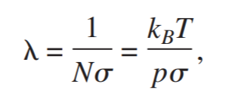
4. The longest mean free path is constrained by the distance between the anode and the cathode. Using the blown-out tube, this is roughly: **1.1*10^(-2)m**.

## Experiment 1 Background & Setup (4/12/2022 CN, AL, JD)

Here is our diagram for the setup. The inputs are sourced to the machines to the left in each connection: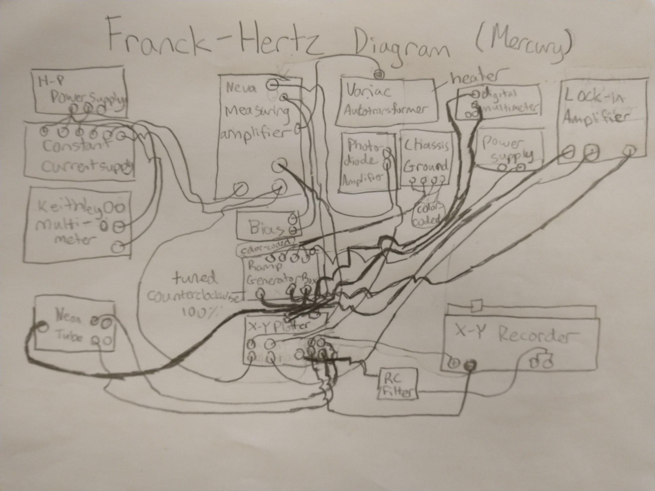Here is a picture for clarity. (some of the machines were moved slightly in the diagram, but they should be close by and identifiable from the photo.)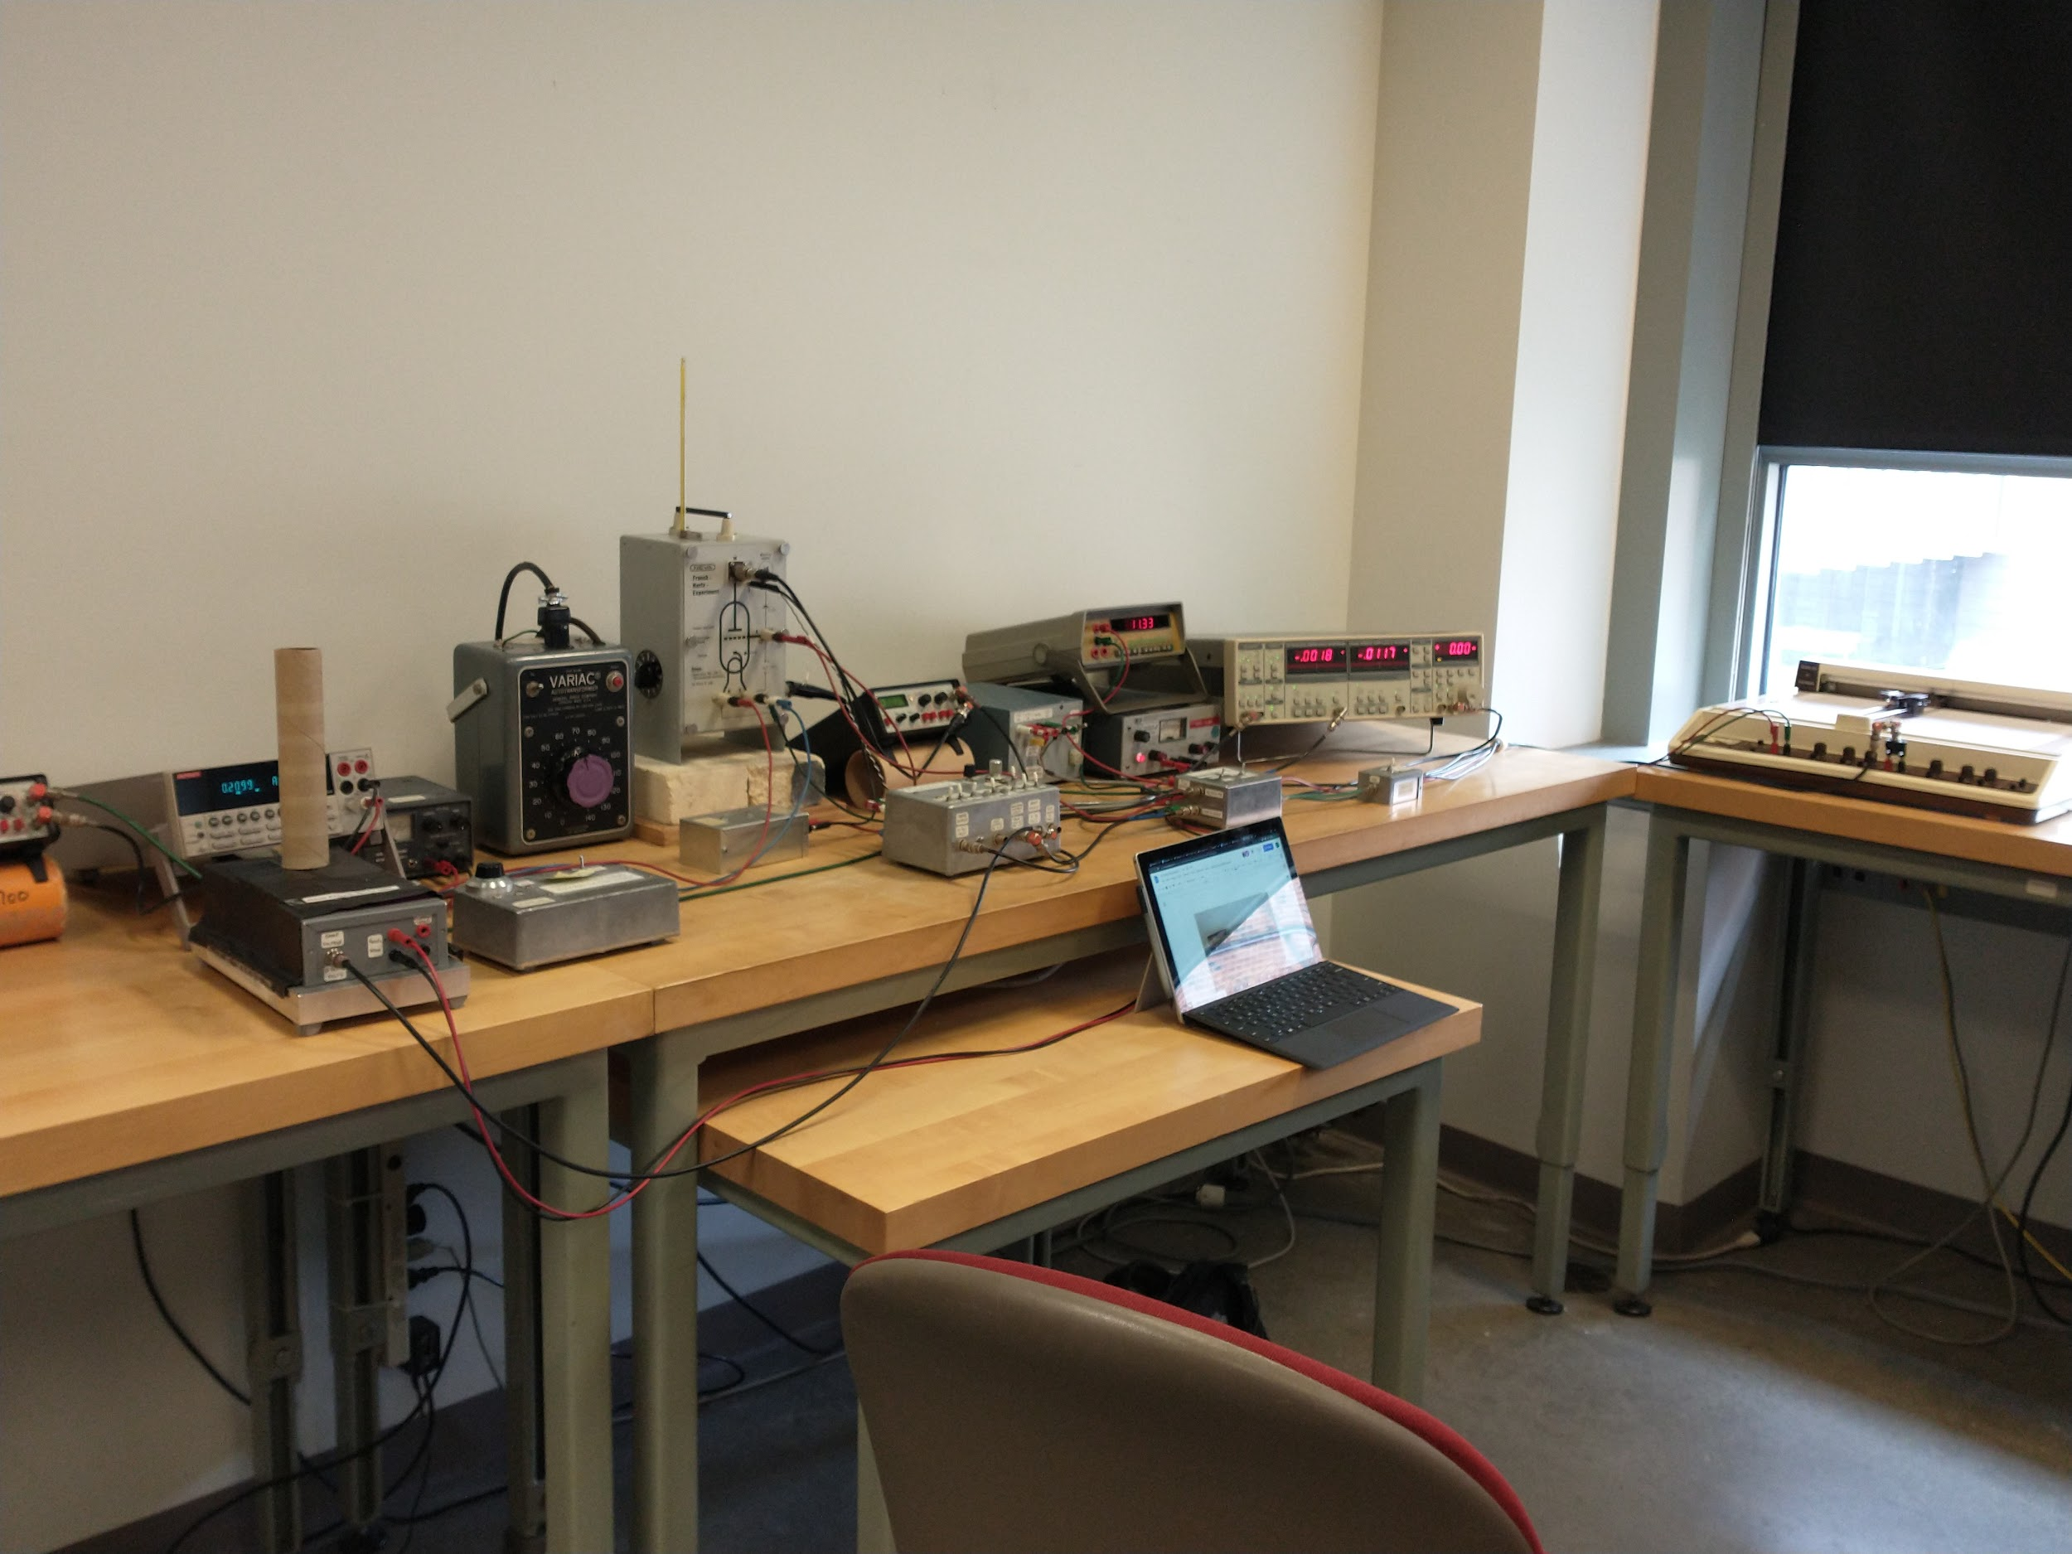

We had to heat up the mercury before the experiment to make it gaseous. For neon, this was not necessary. Most of the wires were already connected from the previous group’s experiment, so we just had to check them, test the X-Y recorder, and then turn everything on in the right order and add the pen to the X-Y Recorder. .

## Experiment 1 Notes (4/12/2022-4/14/2022 CN, AL, JD)

* Temperature: 160C for mercury, room temperature (~25C) for neon
* Constant current supply setting: first mercury graph, 210 mA current; second mercury graph, 212.5 mA; neon graph, 244 mA current
* Autotransformer setting: 65 volts out per 120 volts in
* X-Y Plottersettings: “lock-in” and “mercury setup”
* RC filter setting: “off”
* Ramp generator settings to: “Manual”, “INT”, “Output on”, “-40V” for mercury and -70V for neon, “Modulation Voltage ON”, “Ramp frequency LO”, “Ramp period 250 seconds”, “Pen up/down DISABLE”
* Photodiode amplifier settings: Amps/watt line straight up, Bias down, Range right, Offset left.
* HP Power supply settings: Coarse to the right, Fine down.

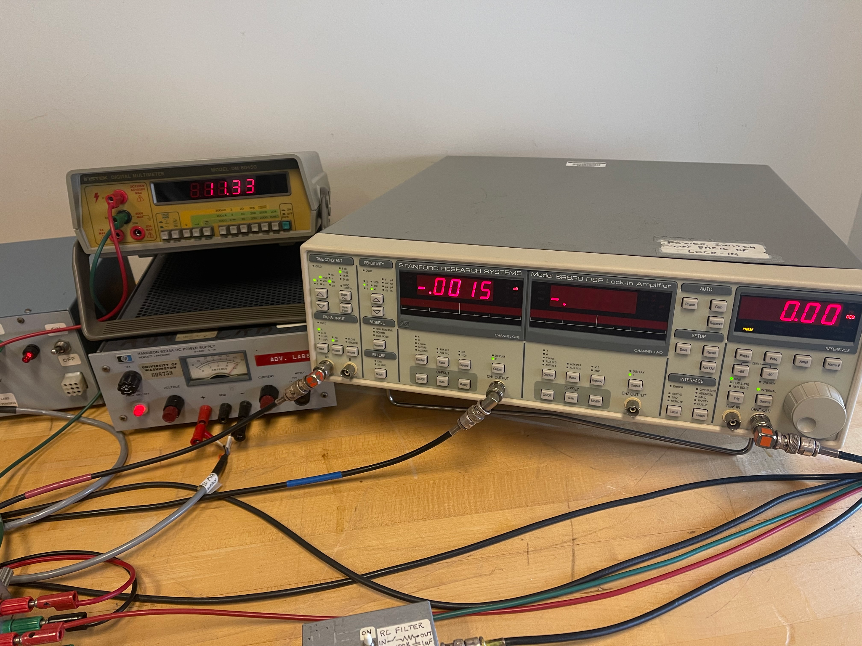

Accelerating Potential: 11.33V

We did 5 points for each of the maximum and minimum accelerating voltages (V) for both Mercury and Neon

**Mercury Data:**

From the group analysis the mercury calibration is 0.25 V per grid which gives instrumental uncertainties of +/- 0.13 V.

For mercury we made 2 runs, one with current supply 210 mA and one with 215 mA. Our analysis is done with the 215 mA run, but the data from both runs is reported in the tables below:

Mercury tables（210mA):

|  |  |  |  |  |  |
| --- | --- | --- | --- | --- | --- |
| Max | 1 | 2 | 3 | 4 | 5 |
| Accelerating Voltage (V) | 11.34+/- 0.13 | 16.18+/- 0.13 | 21.06+/- 0.13 | 26.03+/- 0.13 | 31.14+/- 0.13 |

|  |  |  |  |  |  |
| --- | --- | --- | --- | --- | --- |
| Min | 1 | 2 | 3 | 4 | 5 |
| Accelerating Voltage (V) | 13.20+/- 0.13 | 18.10+/- 0.13 | 23.11+/- 0.13 | 28.24+/- 0.13 | 33.58+/- 0.13 |

Mercury tables（212.5mA):

|  |  |  |  |  |  |  |
| --- | --- | --- | --- | --- | --- | --- |
| Max | 1 | 2 | 3 | 4 | 5 | 6 |
| Accelerating Voltage (V) | 5.91+/- 0.13 | 11.34+/- 0.13 | 16.18+/- 0.13 | 21.07+/- 0.13 | 26.05+/- 0.13 | 31.14+/- 0.13 |

|  |  |  |  |  |  |  |
| --- | --- | --- | --- | --- | --- | --- |
| Min | 1 | 2 | 3 | 4 | 5 | 6 |
| Accelerating Voltage (V) | 7.92+/- 0.13 | 13.06+/- 0.13 | 18.08+/- 0.13 | 23.12+/- 0.13 | 28.25+/- 0.13 | 33.55+/- 0.13 |

Mercury peaks and troughs graph (with derivative function):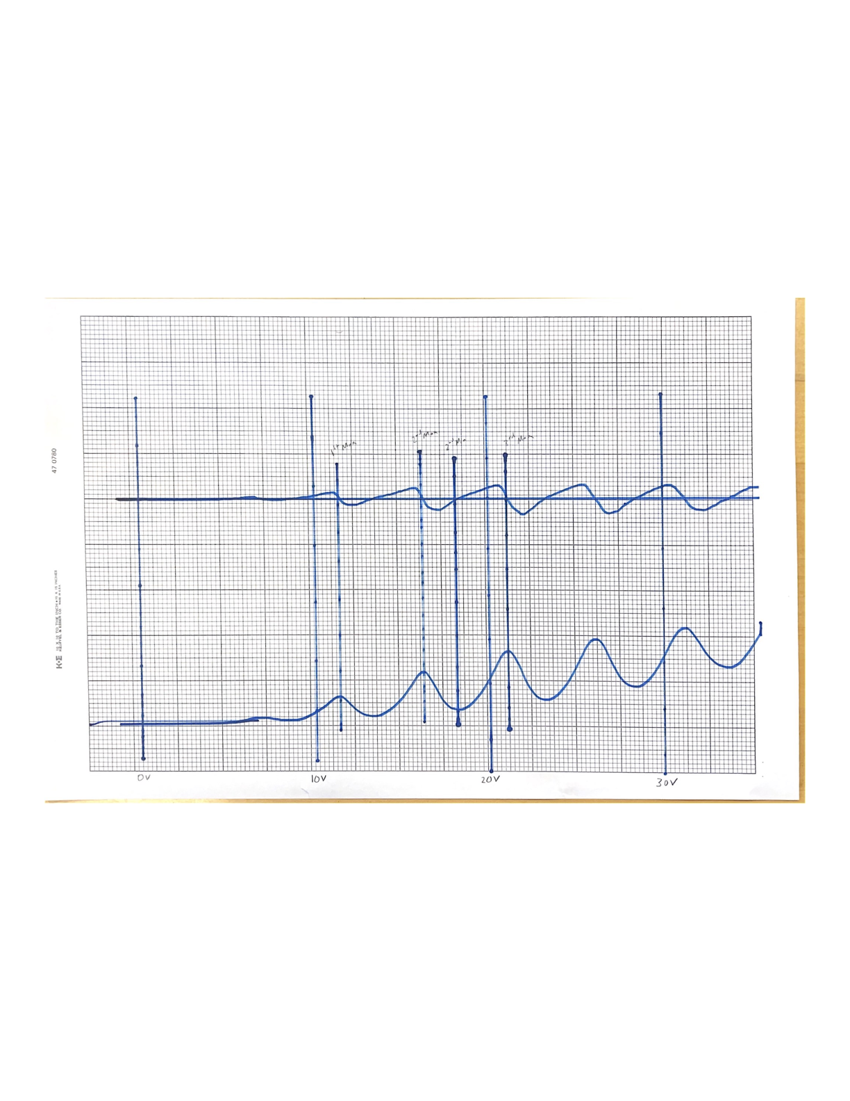

Retaken graph with higher amplitudes from altered current supply:

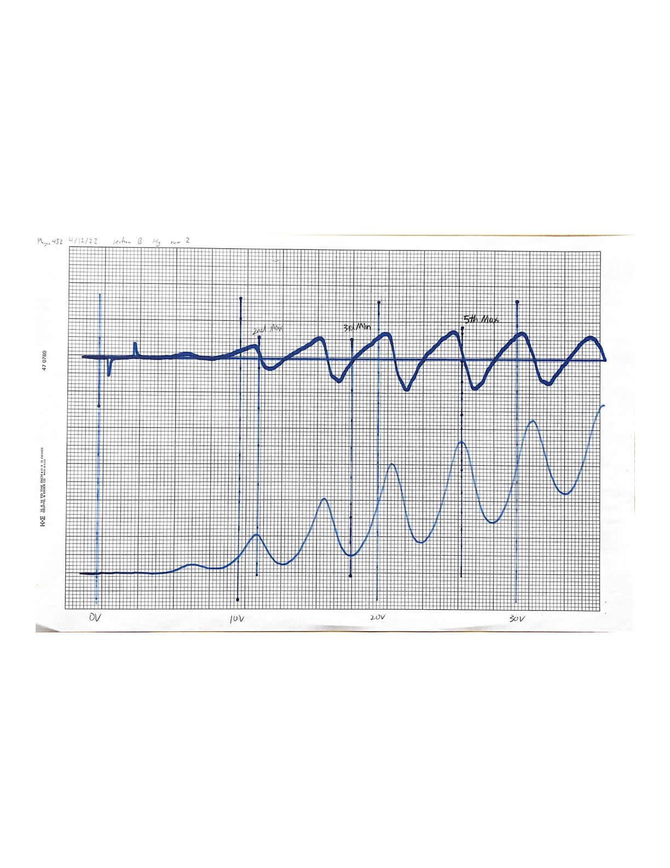

**Neon Data**

From the group analysis, the calibration for neon is 0.49 volts per grid mark, giving instrumental uncertainties of +/- 0.25 V

Neon (244.0 mA):

|  |  |  |  |  |
| --- | --- | --- | --- | --- |
| Max | 1 | 2 | 3 | 4 |
| Accelerating Voltage (V) | 13.28 +/- 0.25 | 30.41 +/- 0.25 | 48.24 +/- 0.25 | 68.24 +/- 0.25 |

|  |  |  |  |  |
| --- | --- | --- | --- | --- |
| Min | 1 | 2 | 3 | 4 |
| Accelerating Voltage (V) | 20.96 +/- 0.25 | 38.10 +/- 0.25 | 57.11 +/- 0.25 | N/A |

Neon peaks and troughs graph (with derivative function):

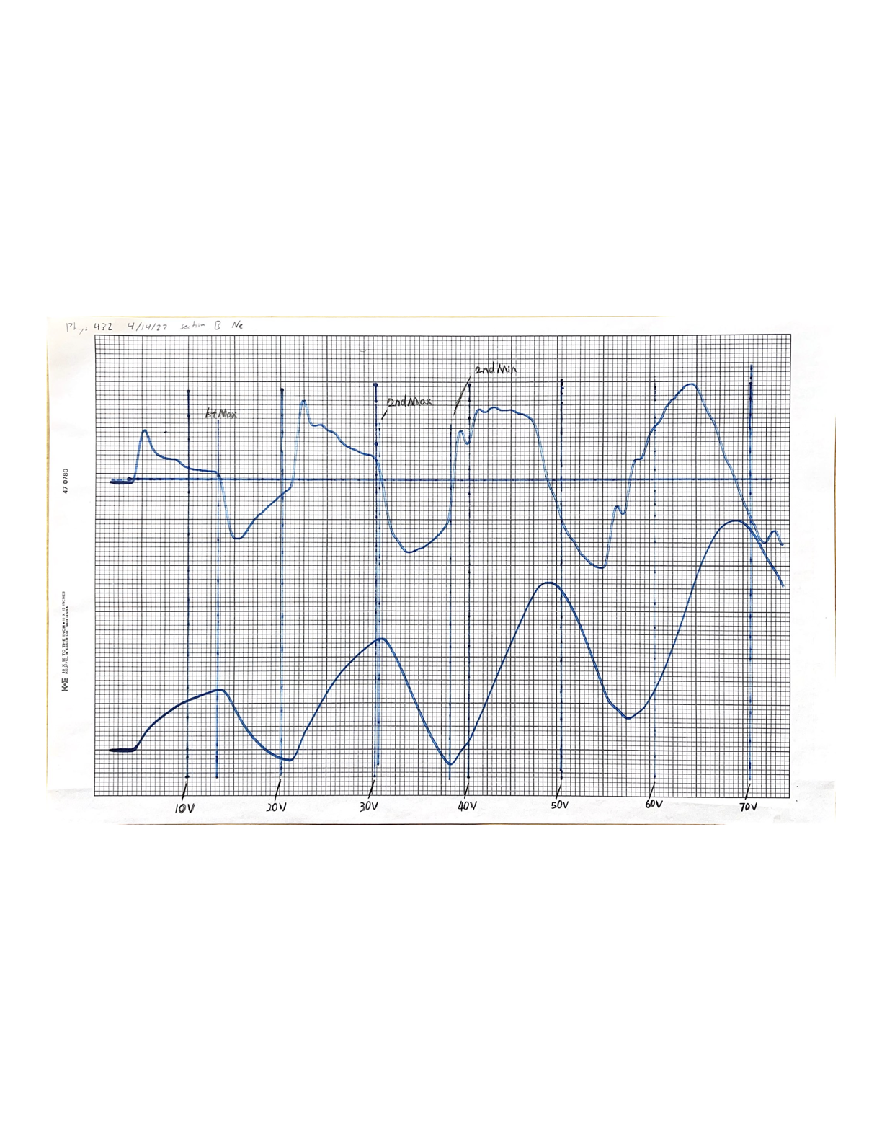

For the calculations, we calibrated the data to the squares then fit the positions of the maxima and minima to linear and quadratic models. This is done in the Python code (attached).

## Experiment 1 Data reduction & Preliminary results (4/12/2022-4/14/2022 CN, AL, JD)

Our values and graphs look about how we expected them to be for the mercury experiment. Our graph amplitudes were smaller than expected, but this did not harm the data analysis, so we kept the original graph, but we took another graph just to be sure and to pick out the features more. We also added a trial to get more data.

For the neon experiment, we got table and graph outputs resembling what we expected completely on the first run. The measurements were in agreement with expected values and easy to read, so we did not have to retake anything.

For initial plots, tables, and calculations, see previous section. For Python data analysis, see the separate pdf attached.

## Experiment 1 Final Analysis (4/12/2022-4/26/2022 CN, AL, JD)

We used a range of currents for the filament depending on substance and how we wanted the graph peak and trough amplitudes to look. For mercury, the optimal current we used was 212.5 mA. For neon, the optimal current we used was 244 mA.

We did not have to perform uncertainty analysis for this experiment except very roughly in analyzing the X-Y plots sketched by the machine to determine if they should be retaken before calibrating the data for Python analysis. For mercury, this meant redoing the graph, but for neon, it came out well on the first try.

To calibrate the data in Python, we had to manually count the positions of critical points on the graphs. We input these positions to create a linear calibration model, which converted grid positions into acceleration voltages. Then, we had to test the calibration to ensure it worked properly. Once it did, we could compare our final outputs to expected results for the experiment.

A plot of mercury peak/trough number vs their measured location in volts with linear and quadratic lines of fit for both peaks and troughs:

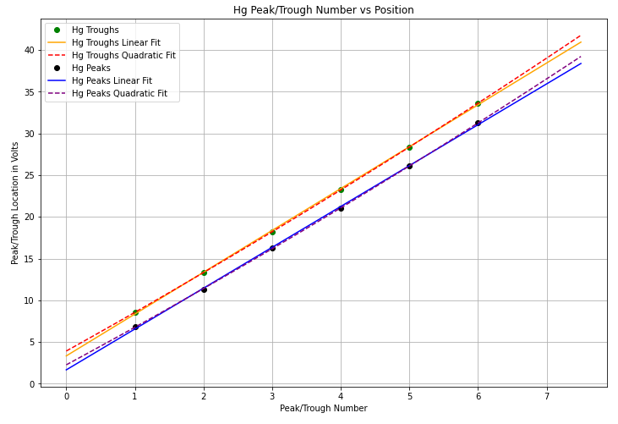

A plot of mercury peak/trough difference numbers and their difference in volts, each with a linear fit.

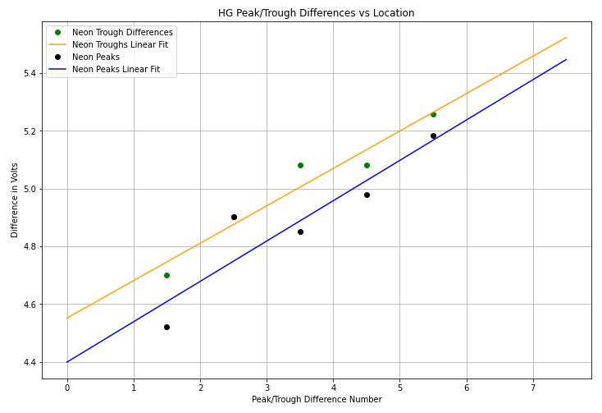

The final results of our measurements for mercury found using the above models are:

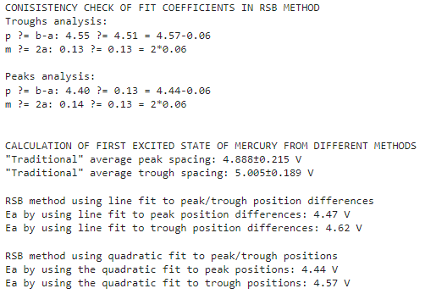

These results are very close to the expected results from the RSB paper. According to the paper, the first excitation of mercury is at 4.67eV. Here we see that using both the linear and quadratic fits for both peaks and troughs gave values that were close to 4.67 V, especially considering that the grids had to be manually counted. The effect of increasing spacing can also be seen in this data as the average peak and trough spacing gave values that were larger than 4.67 V which is expected following the RSB paper.

The mean free path for mercury could also be calculated using our data, and by measuring the distance between the cathode and grid (0.8cm), by using equation (5) in the RSB paper, our measurements gave:

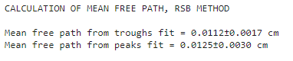

These values are larger than expected by about a value of 2. This could be attributed to the fact that we were unable to measure temperature since the thermometer in the experiment was broken and the Variac device used to heat the mercury did not give temperature readings. It is quite possible that our experiment ran at closer to 140 degrees Celsius, which would agree with our measured mean free path values.

For neon, a plot of peak/trough number vs their locations in volts, along with linear and quadratic fits is:

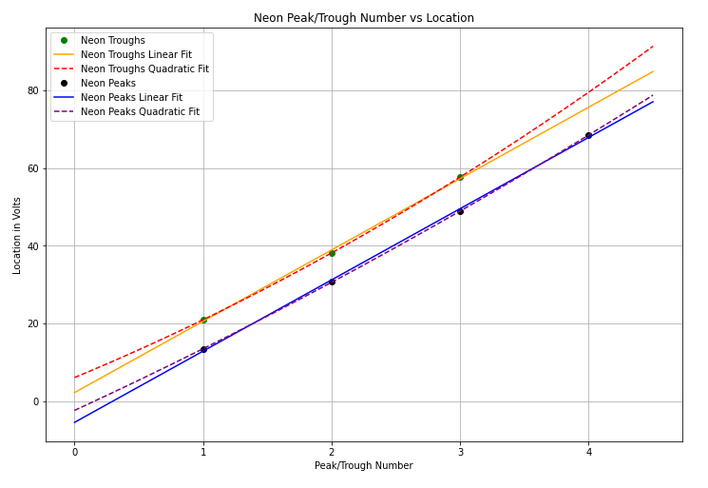

A plot of neon peak/trough difference numbers vs their differences along with linear fits is:

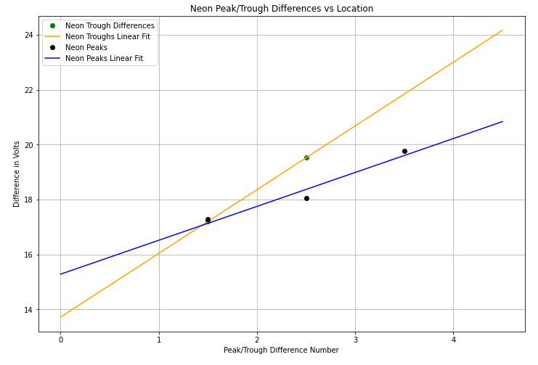

The final results of our measurements for neon using the above models are:

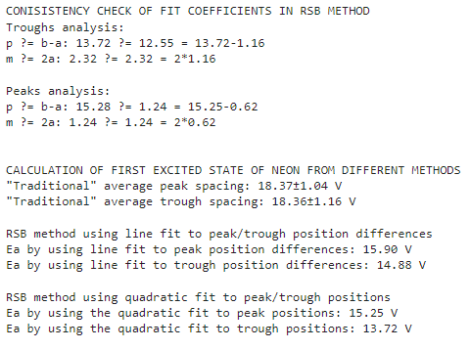

For neon, our results were less accurate, but were still close to that of the RSB paper. The paper found the lowest excited level of neon to be at 16.5 V. Our measurements produced lower values using the same methods, but this can be attributed to the fact that we simply do not have enough data for neon to produce accurate models. The effect of increasing differences with increasing peak/trough numbers is also observed in this data as the average positions were much larger than the values found using the linear and quadratic fits.

Our measurements for secondary features in the lock-in scan gave energy differences:

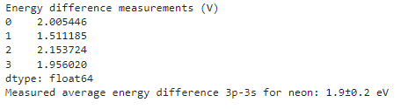

This is also in agreement with the RSB paper. In fact, the RSB paper measured the second excited level to be 1.7 eV which is within the margin of error of our results.

## Experiment 1 Assessment and Discussion (4/19/2022-4/26/2022 CN, AL, JD)

For the mercury, there was only one excited state seen multiple times. Neon had two excited states. Our graphs, when using the optimal currents, look nearly identical to the proper graphs given for examples of this experiment. Additionally, our calibrated tables came out with very similar results to our eyeballed values for the acceleration voltages.

Our mercury results for the first excited state were in agreement with the RBS paper which reported 4.67 eV. From the linear fit we found values of 4.47 eV and 4.62 eV from peaks and troughs respectively. Using the quadratic fit RSB method we found 4.44 eV and 4.57 eV from peaks and troughs respectively. These values are in agreement with the results of the RSB measurements of 4.67 eV. Our mercury results for the mean free path were off by a factor of 2, which can be attributed to our inability to check the temperature and the mean free path being dependent on temperature. We used the expected temperature based on the Variac setting of 65 V, but we were unable to measure the true temperature our data was collected at.

Our neon results for the first excited state were generally lower than those of the RSB paper results of 16.6 eV. Using the linear method we found 15.90 eV and 14.88 eV for peaks and troughs respectively. Using the quadratic fit RSB method we found 15.25 eV and 13.72 eV for peaks and troughs respectively. These values are close to the values given in the paper, but they are significantly lower than the value of 16.6 eV. This can largely be due to our small data sample. We were only able to measure up to 4 neon peaks and 3 neon troughs which lead to inaccurate linear and quadratic models.

The RSB paper also discusses the 3P-3S transition in neon measured at 1.7 eV. We found a value of 1.9 +/- 0.2 eV which covers the RSB value of 1.7 eV. Our neon secondary feature results were in excellent agreement with the RSB data.

Comparing our results with each other, for mercury both the linear and quadratic model values were close. These values were smaller than the values found using the traditional average differences, which agrees with the observation that subsequent peaks and troughs increase in position difference. For neon however, the quadratic model results were significantly smaller than that of the linear model. Once again this is due to the limitations of the number of measurements we could make for neon and thus the number of data points used to create the quadratic model. The linear and quadratic model values for neon were also smaller than the traditional averages showing that spacing increases with peak/trough number.

Overall, our data are in agreement with standard accepted values, with the exception of the mean free path result for mercury and the quadratic fit measurements for neon. Both of these were due to instrumental limitations/error (A ten degree difference in real temperature, for example, would produce the results we see — a factor of two off).

Furthermore, our results are consistent with each other. We saw curved spikes at known energy level values, with the initial graph being smoother and the derivative graph having sharper peaks and troughs.

If we could do the experiment again, we would add equipment to measure the temperature value for the mercury experiment if possible. We would also take more data for the neon values by doing extra trials if time allowed.